TASK 5  
 Output:

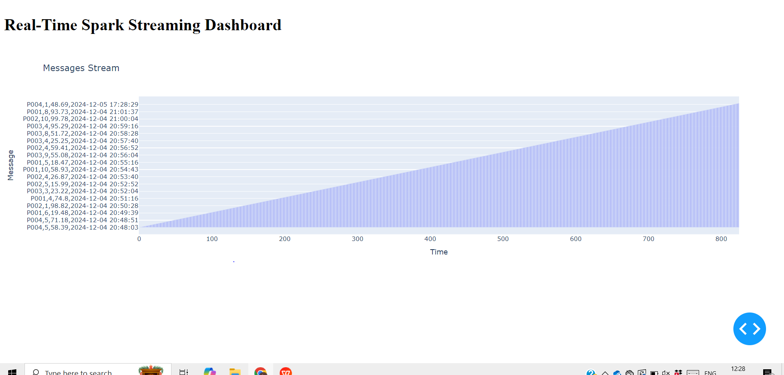

List of commands:  
Python stream_simulator.py  
Spark-submit spark_streaming_task.py  
Python dashboard.py